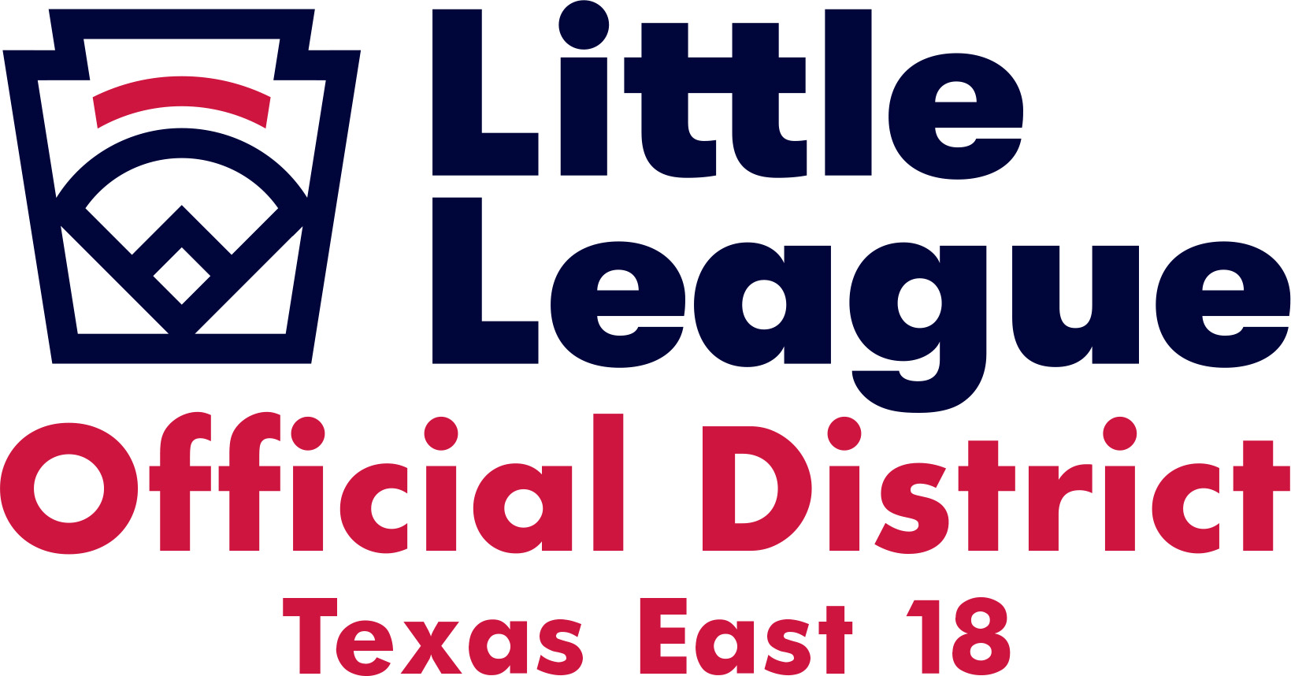

Hotel Information for El Campo, Texas

All the following hotels have rooms blocked off for those needing a room for the State Tournament. Please let them know that you are coming in with Little League.

Best Western Executive Inn
25880 US 59 Road
El Campo, Texas 77437
979-543-7033

Days Inn By Wyndham
25060 US 59 Road
El Campo, Texas 77437
979-320-8878

Home2 Suites by Hilton
25268 US 59
El Campo, Texas 77437
979-488-9795

Thank You,
Paul Sanders
Cell 979-541-6630
sb-umpire@swbell.net
Little League Baseball Inc.
District Administrator
District 18
Texas East Section 4

